**Screenshot of three self-designed queries**

**Prompt 1: Focused Fact Finding**

* **Query:** What is the maximum out-of-pocket expense for an individual under this policy?
* **Intent:** Tests the system's ability to:
  + Locate specific factual information within insurance documents.
  + Handle insurance jargon ("out-of-pocket expense").
  + Provide a concise answer with appropriate citations.

**Input Screenshot**

Top 3 results from semantic search

Top 3 results from generation layer

**Final Output**

**Prompt 2: Understanding Coverage**

* **Query:** Does this policy cover pre-existing conditions? If so, are there any limitations?
* **Intent:** Assesses if the system can:
  + Understand a more nuanced question about policy coverage.
  + Search potentially multiple sections of the documents for relevant information.
  + Present the answer in a clear and well-structured way, addressing both the main question and any limitations.

**Input Screenshot**

Top 3 results from semantic search

Top 3 results from generation layer

**Final Output**

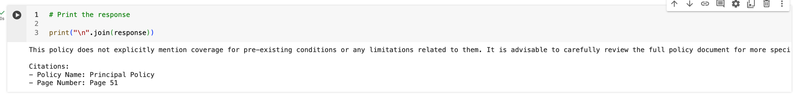

**Prompt 3: Ambiguous Query**

* **Query:** Is this a good insurance plan?
* **Intent:** Tests how Mr. HelpMate AI handles subjective or open-ended queries.
  + Ideally, the system should recognize the lack of objective answerability.
  + A good response would explain that it cannot determine if a plan is "good" without more context about the user's needs, but might offer to help find information about specific factors to consider.

**Input Screenshot**

Top 3 results from semantic search

Top 3 results from generation layer

**Final Output**

